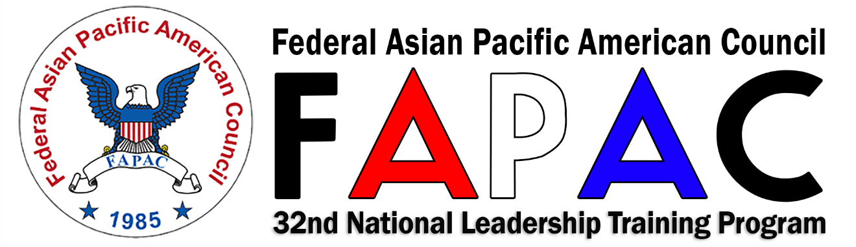

FAPAC 2017 Civilian Awards Announcement
The Federal Asian Pacific American Council (FAPAC) is soliciting nominations for the FAPAC 2017 Civilian Awards. The base period of performance shall be Fiscal Year of 2016, period starting on October 1, 2015 ending September 30, 2016; or Calendar Year of 2016, starting on January 1, 2016 ending on December 31, 2016.

Event, Date and Location:
The awards will be presented during the 2017 National Leadership Training Program (NLTP) to be held on May 15-19, 2017 at the Hilton Washington DC/Rockville Hotel & Executive Meeting Center, 1750 Rockville Pike, Rockville, Maryland.

Purpose:
The purpose of the Civilian award is to recognize and honor individuals who have made significant contributions to the advancement of Asian American Pacific Islanders (AAPIs) and promotion of diversity and inclusion among the Federal and District of Columbia Government work force and the AAPI’s communities.

Award Categories
- Outstanding Individual Leadership: Individual who has exhibited/performed bold leadership and innovative ways in promoting Equal Employment Opportunity (EEO), Affirmative Action and Diversity.
- Excellence in Individual Achievement: Individual who has exhibited/performed the greatest contribution toward the AAPIs representation at all levels as compared to the total AAPI’s population as a whole.
- Diversity Excellence: Individual who has shown a remarkable contribution towards diversity and inclusion through collaboration and against all odds.
NOTE: The Nominating Official must ensure that each agency is limited to one (1) civilian nominee in each category and one nominee in each grade cluster (Grade GS 1-12, Grade GS 13-15, and Grade SES) up to a total of 9 Civilian Award Winners.

Submission Deadline: March 31, 2017
Please submit the nomination packages at www.fapac.org/civilianawards.
Please send any questions to awards@fapac.org.

Evaluation Process:
The Award Committee will comprise of a Panel of Judges to review the application and will use the following evaluation criteria set forth below. Each Criteria will be rated equally as 20 points each, equals to 100%
Criteria 1: Assist the Agency in recruiting, promoting, establishing, and maintaining an effective and equitable participation of AAPIs in the workforce;
Criteria 2: Promote recognition of AAPI's competencies, overall awareness of the impact of AAPIs' cultures, contributions, work ethics, and behavior related to the agency’s employment;
Criteria 3: Promote mentoring, initiate, lead and encourage employees to participate in program activities that will benefit the career training, career development and advancement of AAPIs in the workforce. Establish and maintain channels of communication and goodwill between AAPIs and other members of the workforce;
Criteria 4: Organize program activities that advocate equal opportunity for AAPIs in the Federal and District of Columbia government. Promote a better understanding among AAPIs and non-AAPIs in the workplace and assist to resolve problems of equality for the AAPIs including equal employment opportunities; and
Criteria 5: Achieve personal career development goals in displaying exceptional leadership qualities that will inspire others to follow. Advocate for civil rights, diversity and equal opportunity within the particular department or agency.
The Award Committee will comprise of Panel of Judges and a Committee Chair to review and select the award winner(s) and shall present the results to the FAPAC President for final review and approval. In case of a tie, the Committee Chair will be the tie breaker.
Once the selection of the award winners are approved, the Committee Chair will notify each awardee via email in a formal letter of invitation to attend that is signed by the FAPAC President. The invitation will include a one (1) complimentary dinner ticket to attend the Award Ceremony but it does not include travel expenses for the awardee. If the awardee wishes to purchase additional dinner tickets, this can be done by contacting the Award Committee Chair to purchase additional tickets for additional attendees.
Please direct any additional questions to the award committee at awards@fapac.org.

Submission Process:
Various Agencies may submit a nominee using the attached Nomination Form and based upon the set criteria below. Nomination package from a submitting Agency official must submit packages via www.fapac.org/civilianawards by the above deadline.
Nomination packages shall include, at a minimum, the items listed below. Incomplete packages will not be considered.
- Award Nomination Form (below)
- A Letter of Nomination by the Nominating Official not to exceed two (2) pages (single-spaced, 12 pitch font) that highlights and specifies the achievements related to Nominee for award consideration.
- The Nominee’s curriculum vitae (CV) or resume may be attached to supplement the Nominating Official’s submission.

Award Categories
- Outstanding Individual Leadership: Individual who has exhibited/performed bold leadership and innovative ways in promoting Equal Employment Opportunity (EEO), Affirmative Action and Diversity.
- Excellence in Individual Achievement: Individual who has exhibited/performed the greatest contribution toward the AAPIs representation at all levels as compared to the total AAPI’s population as a whole.
- Diversity Excellence: Individual who has shown a remarkable contribution towards diversity and inclusion through collaboration and against all odds.
NOTE: The Nominating Official must ensure that each agency is limited to one (1) civilian nominee in each category and one nominee in each grade cluster up to a total of 9 Civilian Award Winners.
- Grade GS 1-12
- Grade GS 13-15
- Grade SES

FAPAC 2017 Civilian Awards Nomination Form

Please choose one Award Category and One Grade Cluster:

☐ Outstanding Individual Leadership
☐ Excellence in Individual Achievement
☐ Diversity Excellence
☐ Grade GS 1-12
☐ Grade GS 13-15
☐ Grade SES

Nominee Information:
Name of Nominee
Position/Title
Grade
Department/Agency
Mailing Address
Work Phone Number
Email

Nominating Official Information:
Name of Nominating Official
Position/Title
Grade
Department/Agency
Mailing Address

Work Phone Number
Email
Signature of Nominating Official

Civilian Awards Evaluation Factors

Please provide supporting narrative.
- Assist the government in recruiting, promoting, establishing, and maintaining an effective and equitable participation of AAPIs in the workforce

- Promote recognition of AAPI's competencies, overall awareness of the impact of AAPIs' cultures, contributions, work ethics, and behavior related to the government employment

- Promote, initiate, lead and encourage employees to participate in program activities that will benefit the career training, career development and advancement of AAPIs in the workforce Promote a better understanding among AAPIs and non-AAPIs in the workplace and resolve problems of equity for the AAPIs including EEO. Establish and maintain channels of communication and goodwill between AAPIs and other members of the workforce
- Organize program activities that advocate equal opportunity for AAPIs in the Federal and District of Columbia government

- Achieve personal goals in displaying exceptional leadership qualities that will inspire others to follow

Advocate for civil rights, diversity and equal opportunity within their particular department or agency

