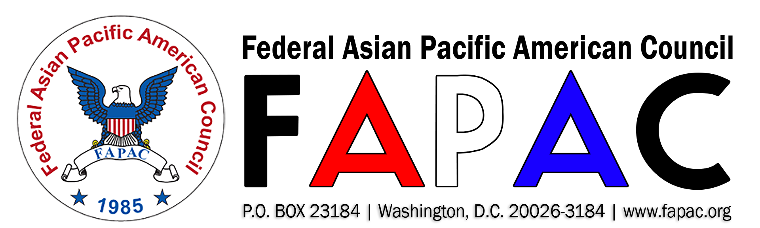

“Promoting Equal Opportunity and Cultural Diversity for APAs in Government”

2018 FAPAC CAREER DEVELOPMENT PROGRAM (CDP) ANNOUNCEMENT
The Federal Asian Pacific American Council (FAPAC) is now accepting applications for its 2018 Career Development Mentoring Program (CDP). The program begins April 2018 through October 2018. Training sessions will be held in the Washington, DC metro area.
The CDP is a tuition-free program that offers individual mentoring, professional development, and career counseling for high-performing federal employees. Forty participants will be selected for the 2018 program (20 mentors and 20 mentees).

Mentoring objectives include:
- A diverse network of dedicated public servants;
- Strengthening personal goals and career planning;
- Leadership training; and
- Access to career advancement workshops.

Who May Apply:
- Current federal employees with permanent career status.
- Mentee candidates must be GS-13 or lower.
- Mentor candidates must be GS-14 or higher and 8+ years in federal service.

Application Requirements:
- Resume (no more than 3 pages)
- Completed 2018 FAPAC Career Development Program Application Form, must submitted 4 weeks after the announcement is posted.
Submit completed applications by email to mentoring@fapac.org. Late or incomplete applications will not be considered and marked “ineligible.”
For more information, visit http://www.fapac.org/cdp or contact 2018 FAPAC Program Chair: Cailine Kim at cailine.kim@fapac.org or Co-Chair: Sara Kaul at sara.kaul@fapac.org.

